2. Data Split-Up and Cross Validation

Aim:
To split the dataset into training and testing data and perform cross-validation using Python to evaluate the performance of a machine learning model.

Algorithm
- Start the program.
- Import the required libraries from Scikit-learn.
- Create a sample dataset containing input features and target values.
- Split the dataset into training and testing sets using train_test_split().
- Create a machine learning model.
- Apply cross-validation using cross_val_score().
- Calculate and display the cross-validation scores.
- Display the training and testing data sizes.
- Stop the program.

CODE AND OITPUT:

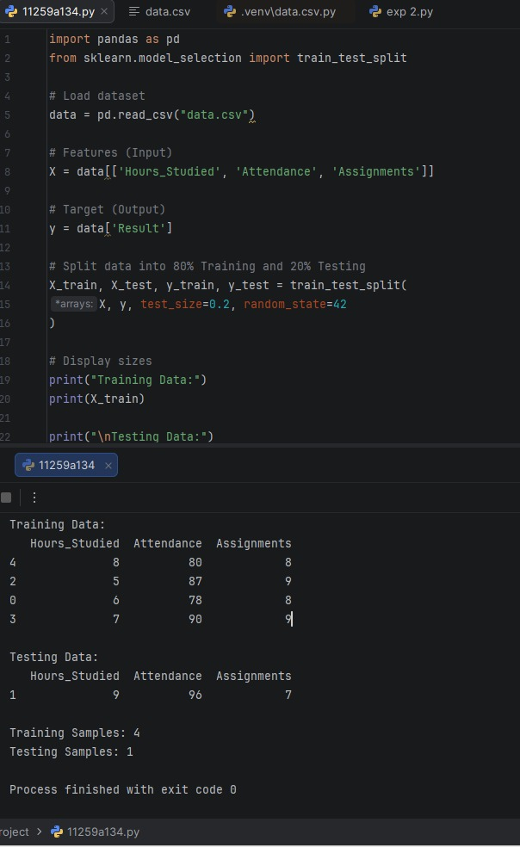

Result:
Thus, the dataset was successfully split into training and testing sets, and cross-validation was performed to evaluate the performance of the machine learning model.

Data Split-Up and Cross Validation

Aim:
To split the dataset into training and testing data and perform cross-validation using Python to evaluate the performance of a machine learning model

Algorithm:

1.Start the program.
2.Import the required libraries from Scikit-learn.
3.Create a sample dataset containing input features and target values.
4.Split the dataset into training and testing sets using train_test_split().
5.Create a machine learning model.
6.Apply cross-validation using cross_val_score().
7.Calculate and display the cross-validation scores.
8.Display the training and testing data sizes.
9.Stop the program.

CODE AND OITPUT:

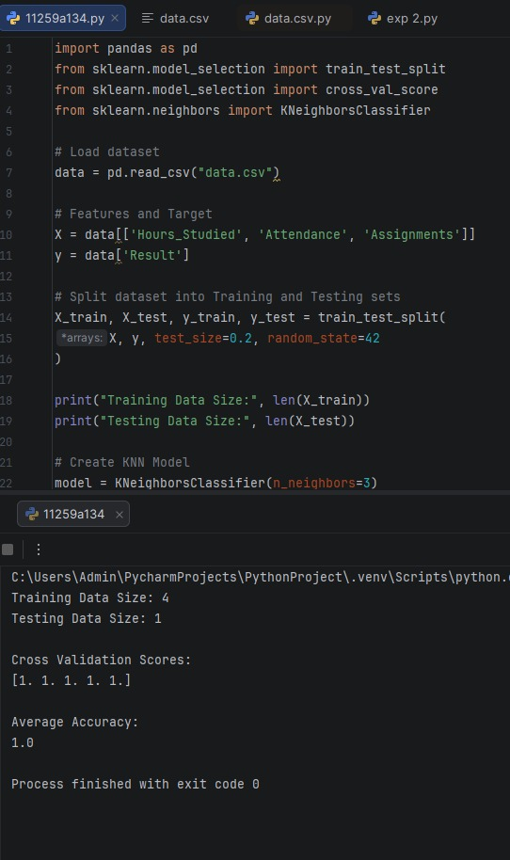
Result:
Thus, the dataset was successfully split into training and testing sets, and cross-validation was performed to evaluate the performance of the machine learning model.

